# OBJECTIVE:

**LAB # 5**

# Start, Sleep and Stop methods of multithreadin

Understanding concurrency by implementing start, sleep and stop thread function

Lab Task:

By using start, stop and sleep methods of threading, print alphabets of English from A-Z. (Hint: use math.random method for getting random numbers and then convert them into characters, print 26 characters under rum method loop with fluctuating visualization through sleep method).

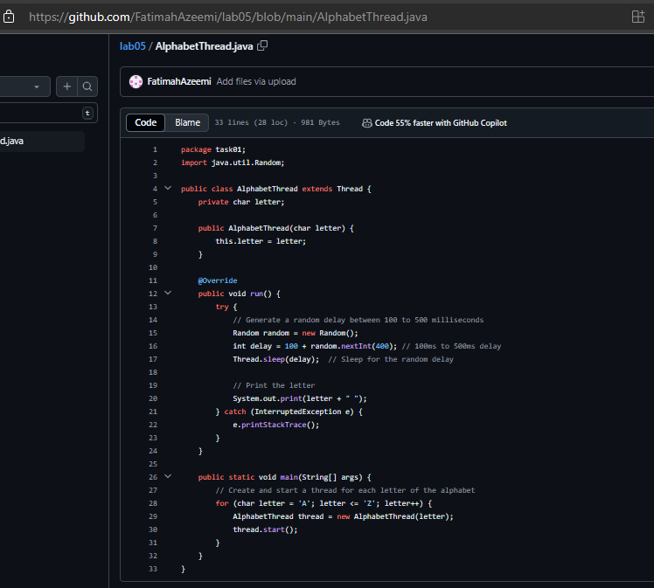

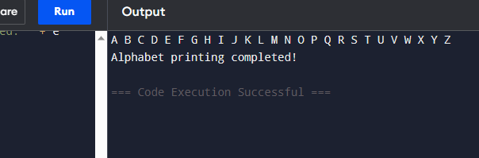

Lab Task:

By using start, stop and sleep methods of threading, print alphabets of English from A-Z. (Hint: use math.random method for getting random numbers and then convert them into characters, print 26 characters under rum method loop with fluctuating visualization through sleep method).